PROJECT DESIGN PHASE II DATA FLOW DIAGRAM AND USER STORIES

|  |  |
| --- | --- |
| Date | 16 October 2022 |
| Team ID | PNT2022TMID52458 |
| Project Name | DEMANDEST – AI POWERED FOOD DEMAND FORECASTER |
| Maximum Marks | 4 Marks |

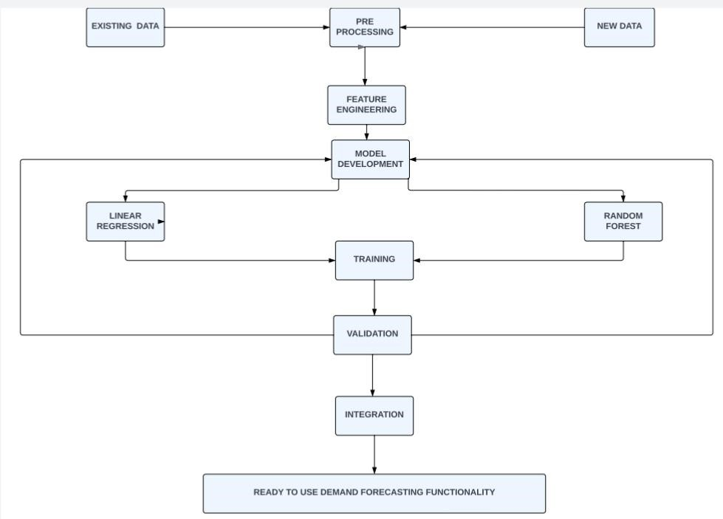

|  |  |  |  |  |  |  |
| --- | --- | --- | --- | --- | --- | --- |
| User Type | Functional  Requirement  (Epic) | User  Story  Number | User Story / Task | Acceptance criteria | Priority | Release |
| Customer (Webuser) | Registration | USN-1 | As a user, I can register for the application by entering my email, password, and confirmingmy password. | I can access my account / dashboard | High | Sprint-1 |
|  | Verification | USN-2 | As a user, I will receive confirmation email.Once I have registered for the application | I can receive confirmationemail & click confirm | High | Sprint-1 |
|  | Login | USN-3 | As a user, I can login to the application by entering email and password. | Check whether passwordand email is correct | High | Sprint-1 |
|  | Dashboard | USN-4 | If the email id and password is correct, the user can log in to the application otherwise itshows ‘incorrect password or Id’. | View the dashboard of  user who is log  in | High | Sprint-1 |
| Customer Care  Executive | Help | USN-5 | If the user faces any issues, he/she can reportit to our mail id. | Report option will be available in  web app | High | Sprint-2 |
|  |  | USN-6 | We can provide an alternative solution to the problem. | We get the update of the alternate solution. | High | Sprint-3 |
|  |  | USN-7 | As admin I can provide some recommendation of the mostly purchased products. | I get recommendations from the centers | medium | Sprint -3 |
| Administrator | Verification | USN-8 | Administrator also has unique Id and password to login. | Check whether password and email is correct | High | Sprint-4 |
|  |  | USN-9 | He has additional users to organize the users of this web app | Checking user information. | High | Sprint-4 |